CS 257

Jamie Emery

Michael Stoneman

Joe Adkisson

**Senate Vote Record Viewer Mockup**

**User Story #1:**

**User:** Mr. Jonny McPoliticallyInept is curious about how his home senator voted on a particularly politically charged bill that he heard about in the news recently. Jonny does not know the name of his senator but he does know what state he lives in but he does know the bill.

**Story Branch #1**

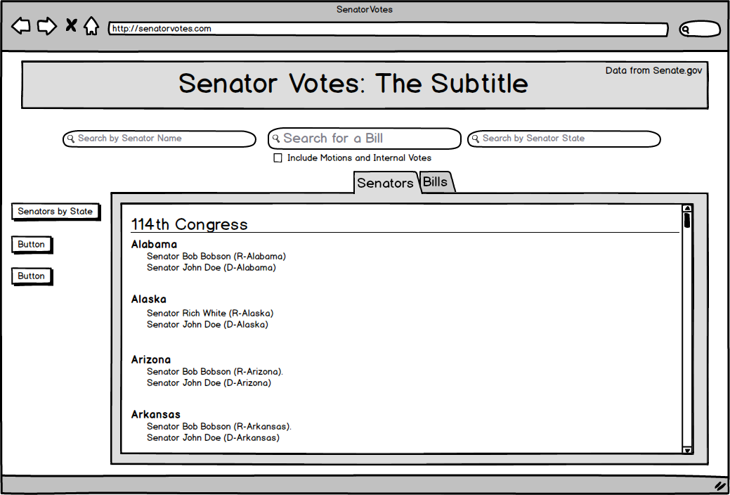

Step #1: Jonny reaches the homepage and sees the search bar. He enters the HR number of the bill into the search bar and is taken to a page that lists links to all of the bills bearing that HR number, listed by congressional session.

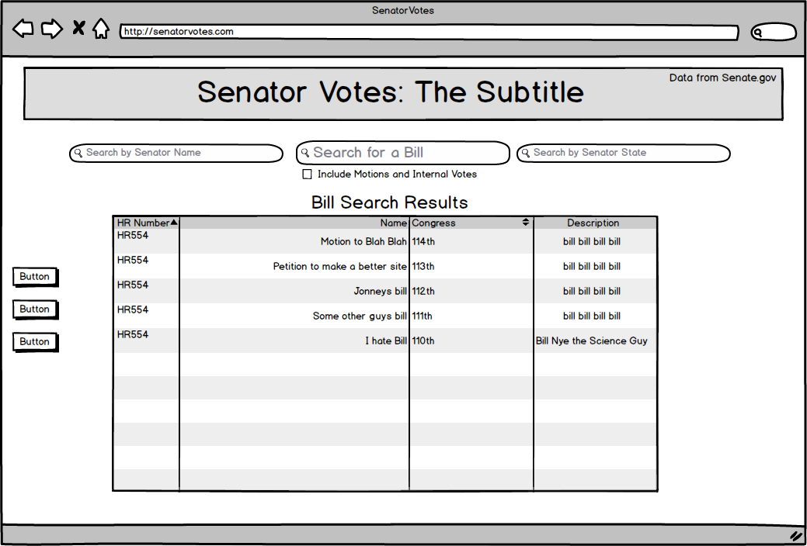

Step #2: Jonny finds the bill he is looking for based on its named and clicks on the link for his specific bill and finds a page that lists how each senator voted on the bill organized by party, then state

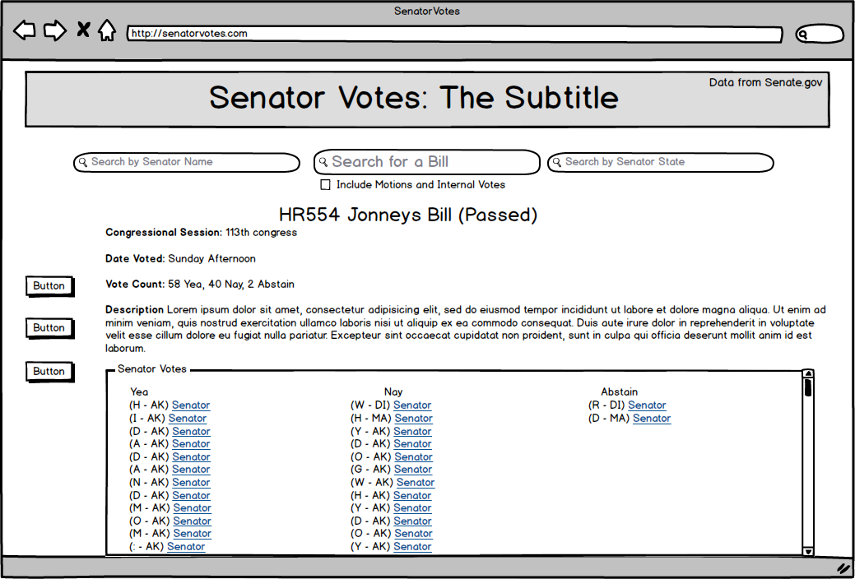

Step #3: Jonny looks through the list of how senators voted and finds the his state and senators, Jonny has won.

**Story Branch #2**



Step #1: Jonny reaches the homepage and sees the senators by state. He clicks on it and finds a list of all the states in the union, listed alphabetically. He clicks on his state.

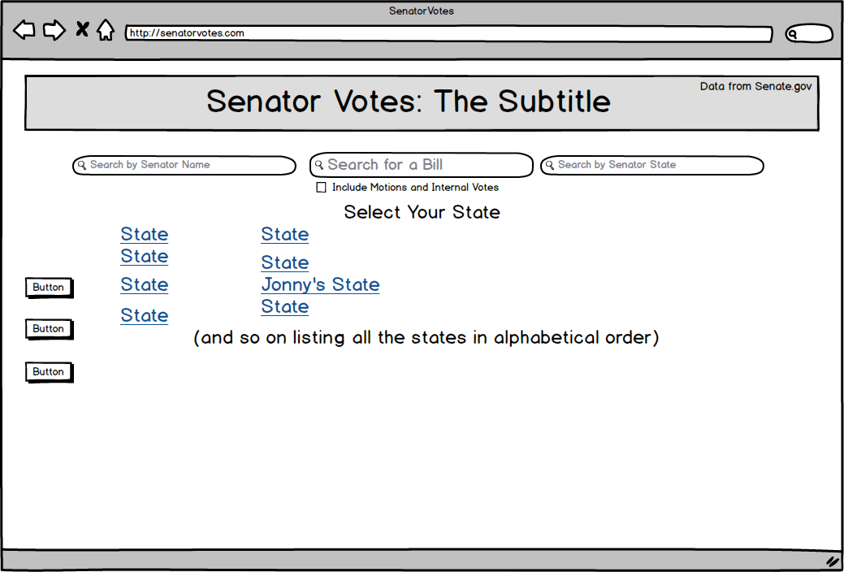

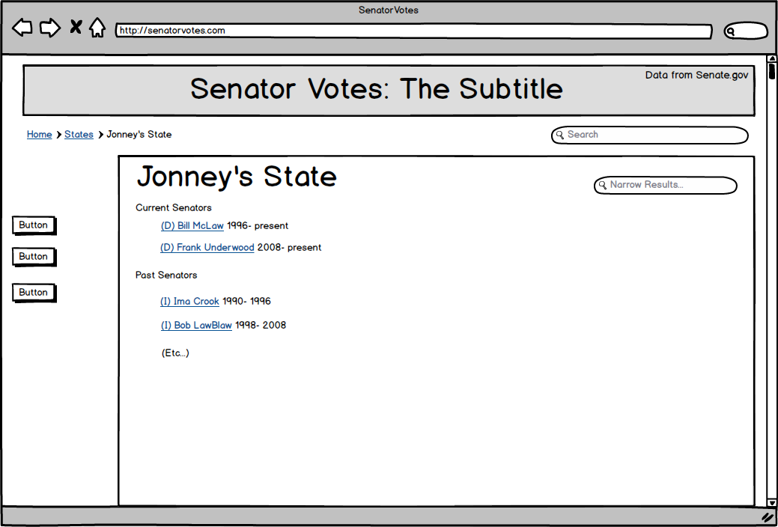

Step #2: Jonny is confronted with a webpage for his state listing the current and past senators in the database for the state. Jonny finds the senator he is interested in and clicks on his name.

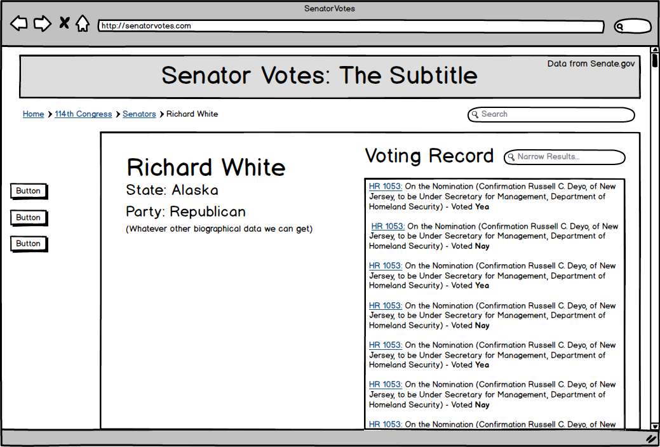

Step #3: Jonny finds a page that lists some basic information about his senator and a list of the most recent bills his senator has voted on, Jonny does not find the bill he is looking for so he types info about the bill he is looking for into the narrow results page



Step #4: Jonny is confronted with an even longer list of recent bills voted on by the senator but still he does not see what he needs so he enters into the “search bills voted by <senator>”    the hr number of the bill he was looking for and is taken to a search results page that lists the bills that come up and how <senator voted>

**User Story #2:**

**User:** Ms. Nosi McActivist is a journalist with strong political leanings. While she can’t *prove* that congressman Richard White has been flipflopping on an issue, she’s all but positive, and is on the site to find the proof she needs.

**Story Branch #1**

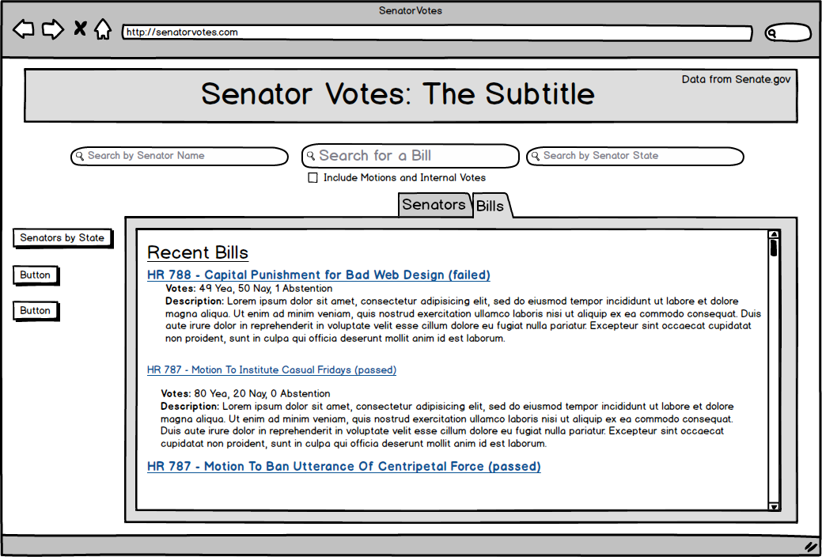

Step #1: Nosi reaches the homepage and sees the search bar. She searches for <issue>, and is taken to a page that lists (in brief form) bills that match the issue, in reverse chronological order.

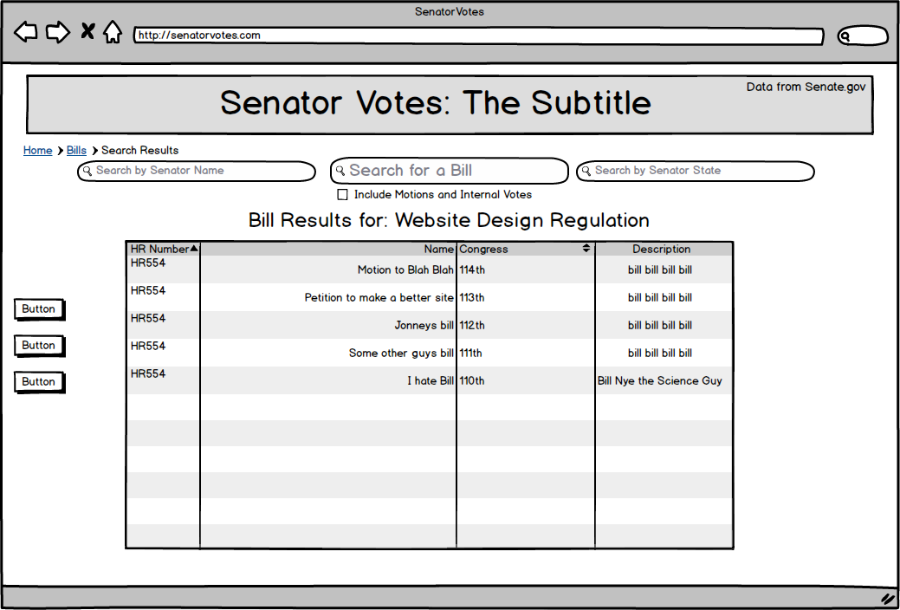

Step #2: Nosi sees a high-profile bill, and clicks on it. This takes her to the bill’s page.

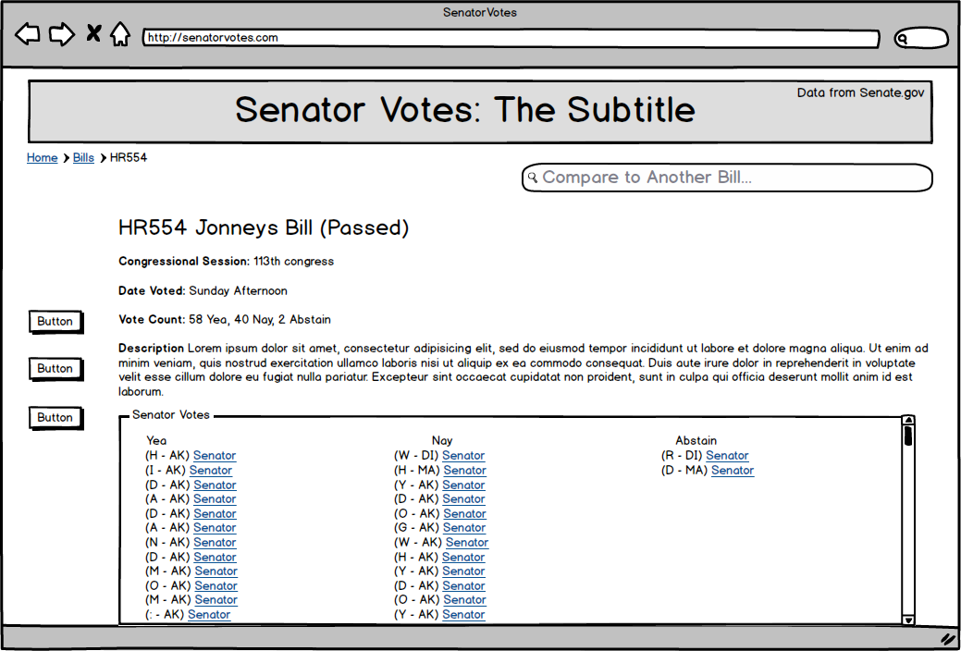

Step #3: Types a Query into the search bar reading “Compare to Another Bill.” She is then presented with a search bar. She enters the name of a topic she is interested in and comes up with search results for the bill she’s interested in.

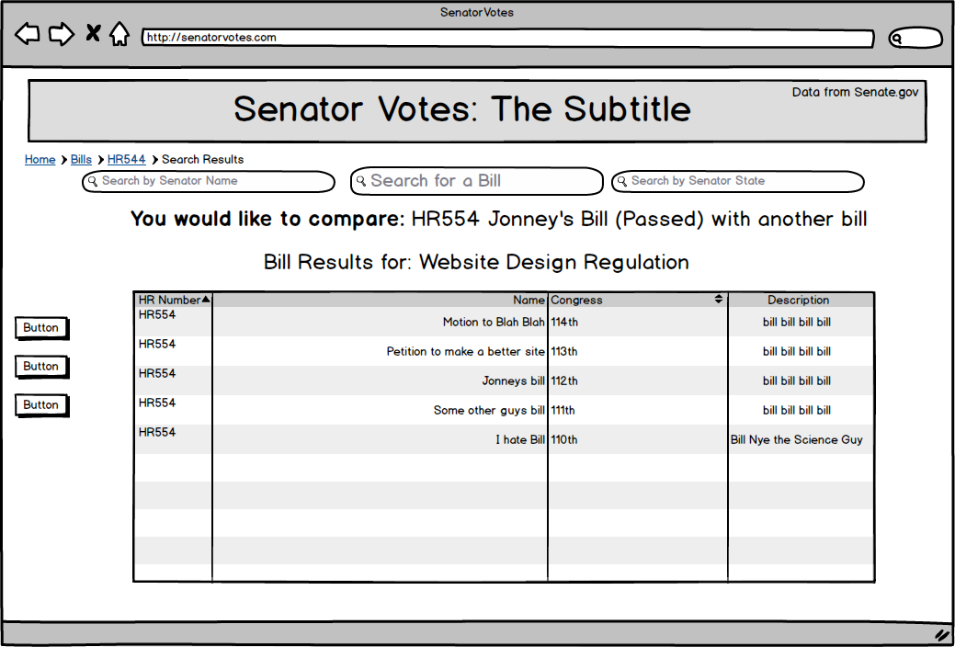

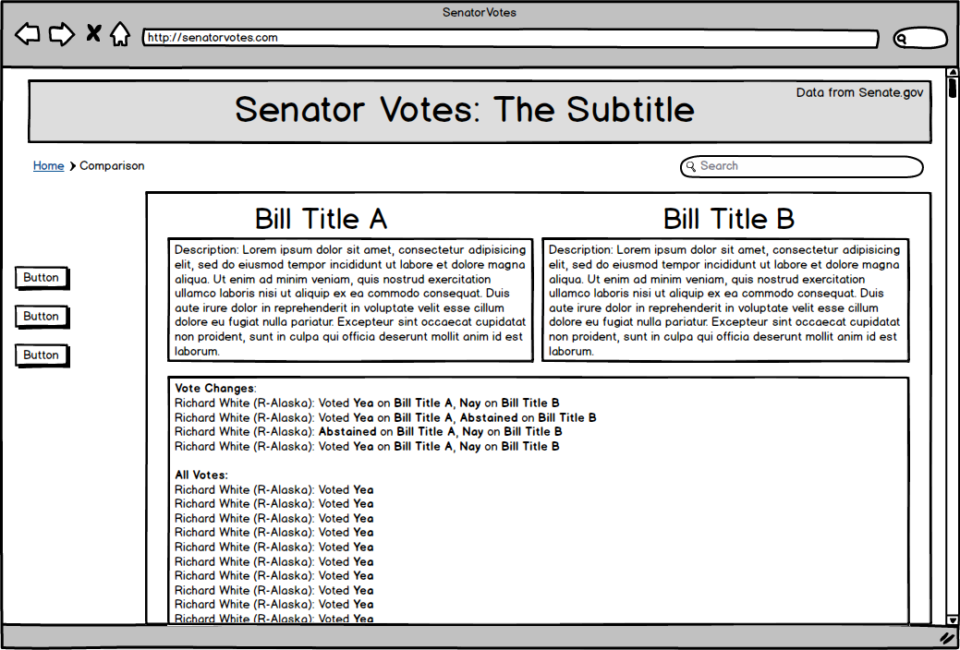

Step #4: She selects one, and it pops up a comparison screen of the votes on the two bills. She scrolls down to Richard White’s name and can see what he voted on the bills. She wins!

**Story Branch #2**



Step #1: Nosi reaches the homepage and sees the search bar. Since she’s curious about Richard White, she types his name in.



Step #2: On the right half of Richard White’s page, Nosi sees his voting record – all of the bills she’s interested in are there, but so are the others, listed in reverse chronological order. She goes to the “Narrow Results” search bar, and searches for Website Design Regulation.

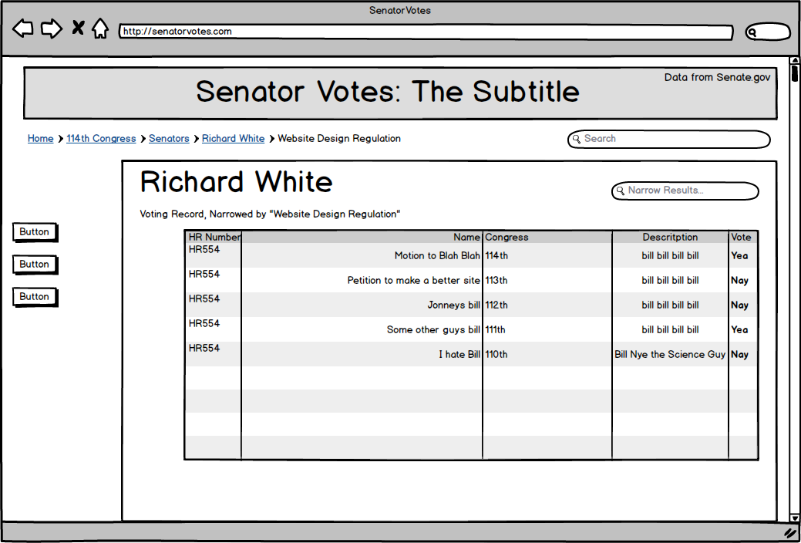

Step #3: The new page displays only the subset of the bills that the search returns, complete with Senator White’s vote on each one. Nosi can easily see that he has changed his vote. Nosi wins!

**User Story #3:**

**User:** Mr. Clueless McUninformed is a Carleton student who has only recently gotten into politics. A friend linked him to a specific bill’s page at a campus political meeting, and he’s not sure where to go from there.

**Story Branch #1**

Step #1: Clueless lands on the bill’s page, and looks around. He looks through the bill’s details and finds what he needs about the bill.



Step #2: Clueless is curious about the website – it is, after all, quite well made. His favorite senator is Richard White, and on a whim, he decides to check out Mr. White’s page by entering his name into the search bar.



Step #3: Admiring the nice layout, Clueless decides to see who made this site. He clicks on the logo, taking him to the homepage.

Step #4: He sees the legitimacy of the website and bookmarks the homepage, knowing how useful it could be in the future. Clueless wins!